News Letter

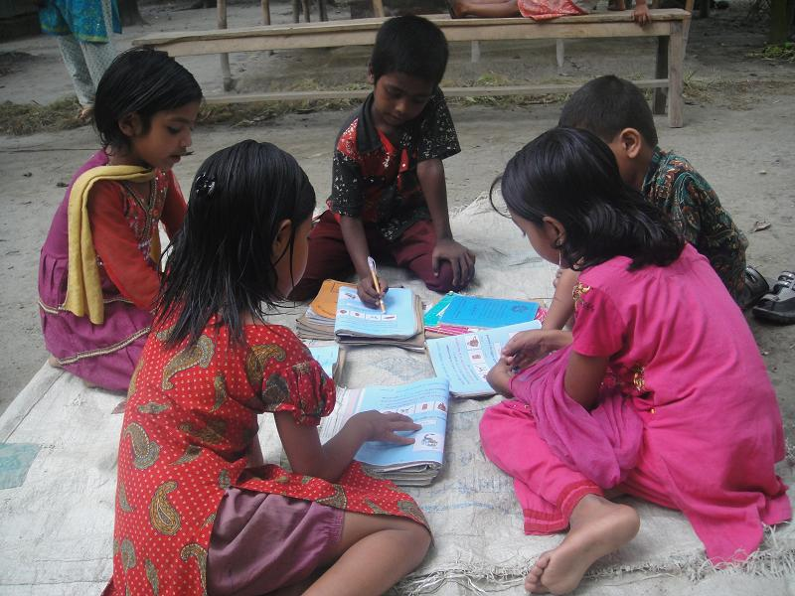

Submitted by: POPI
People’s Oriented Program Implementation
5/11 –A, Block –E, Lalmatia , Dhaka – 1207.
E-mail: popi@bdmail.net
Website: www.popibd.org
A MASSAGE FROM OUR TEAM
Dear Friends,
Welcome to our Newsletter! We hope this will provides you with a half yearly look at some of our highlights: from learning about our work to provide educational opportunities to those most in need, to hearing from those among us who allow us to grow and continue doing this inspiring work.

In a time where we all face uncertainty, we want to thank you for continuing to support CEP Project and our efforts to provide better opportunities for children throughout the project area. We have always our promises to remain sharp focus on scaling up the quality. We thank you for your continued confidence in us as we strive to be the premier organization focused on Child Rights.

PLAYFUL EARLY LEARNING 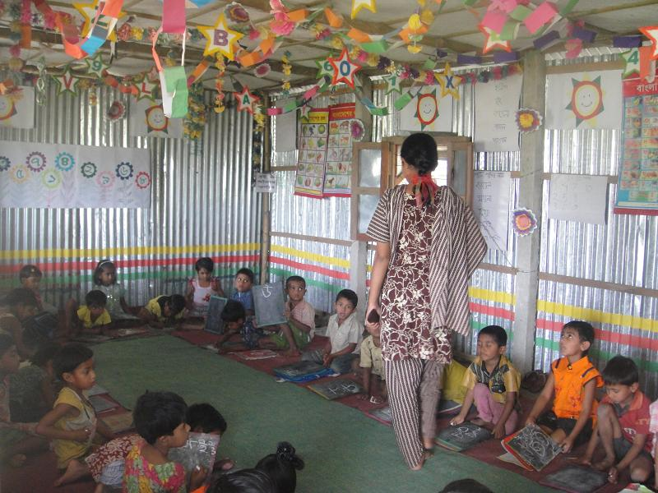
Sweety,6, in Early Learning class with other children

Sweety lives in a small dark room fenced by matted bamboo slips in Chonchora village in Kalikaprosad union under Bhairab Upazila.
In the early morning, Sweety wears her dress, combs her hair, takes her books and gets ready to go to school.
“I enjoy every minute of my time in the school. I always shares rhymes and stories that I learn in class with other children in the neighborhoods,” said Sweety, a student of ECD center of Pultakandi Formal Primary School.
Sweety also said, “We like our school. It is well decorated, full of fun and excitement. We play with a lots of friends.”
Sweety along with other 30 children attends pre-school at Pultakandi Formal Primary School that carried out by the CEP Project through the school preparedness initiative.
The learning for Early Childhood Development (ECD) is designed to assist children aged five to six from disadvantaged families to develop their learning skills and to prepare them for formal schooling.
“The centre is very different with traditional schools. The classroom is beautifully decorated. My daughter
play sings songs, learn rhymes and story, and share with me. Even I also learn as I attend in parents meeting about the wellbeing of children.” said Khaleda Begum, Sweety’s mother, who works as a maid.
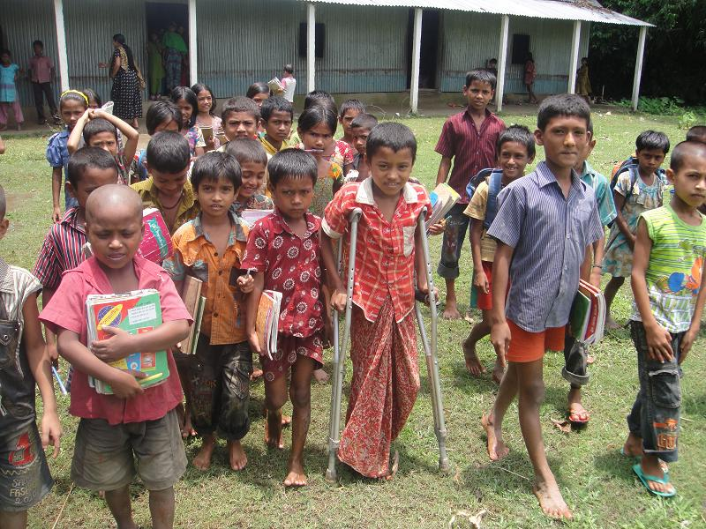
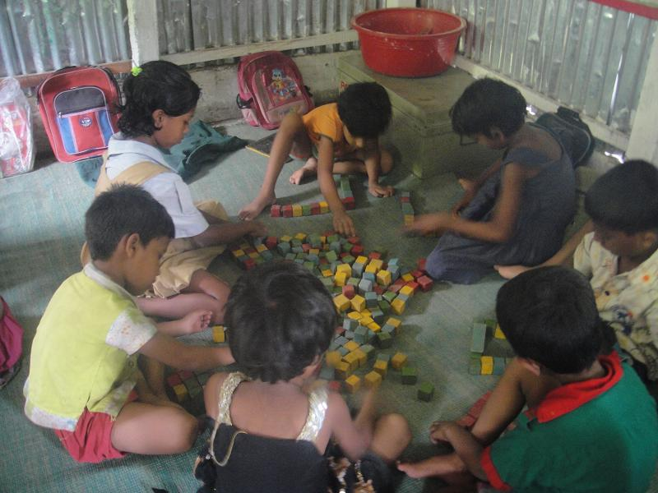
Children learn by playing

“Children learn through active participation of games where they learn discipline as well as respect to another. Children never feel bored in class because we always try to create a joyful learning environment for them.” said class teacher Shahida Akter who has been teaching early children since 2009. ☼

CHANGING LIVES OF CHILDREN WITH DISABILITIES
Taslima Begum is preparing her seven-year-old son Bayejit for school. Two class mates of Bayejit are waiting for him in the yard. Soon Bayejit join with these boys to go school. His mother looks them
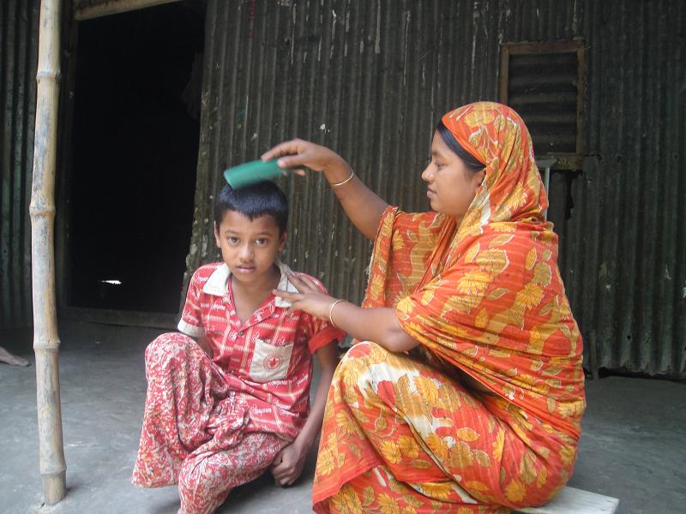
Bayejit with his mother r
r
behind. There is no difference among three children except Bayejit uses crutch to walk.
Bayejit’s father Jasim uddin was working in a grocery store and lived in Azimpur slum in Dhaka city where Bayejit with his mother went for few days to stay with his father. In July 2010, Bayejit experienced the most devastating incident in his life.
It seemed like any other day. Bayejit was playing on the road with other children. Suddenly a truck exhausts Bayejit and one leg severely injured. Bayejit immediately report to hospital. After examine the situation, Doctor decides to cut off one leg from under the knee.
Bayejit faced the real challenge after come back home. He used to watch other children walk to school everyday, not knowing if he would ever be able to join them. In January 2011, when children have been started to enroll in school, his mother hesitates to enroll
Bayejit with his class friends

Bayejit in school for his difficulties to go to school. Finally she came across Head teacher of South Salua
Primary School. His Head Teacher Reba Rani said, “When Bayejit’s mother, Taslima, came for her son’s admission she appeared very emotional and worried. She was confused since our school did not have any student with such kind of severe physical impairment.”

“When I was in dark about the future of my son, then Reba Rani, the head teacher of South Salua school, helped me lot. She inspired me and tried to make confidence me. I started to realize my son’s potentials in spite of his physical difficulty. I enrolled him in class one. Now he goes to school regularly and more active about his school. I want to give thanks to the teachers for their cordial cooperation.” said Taslima Begum.

“All the teachers have the affection for Bayejit. We take special care for him.” said Reba Rani.
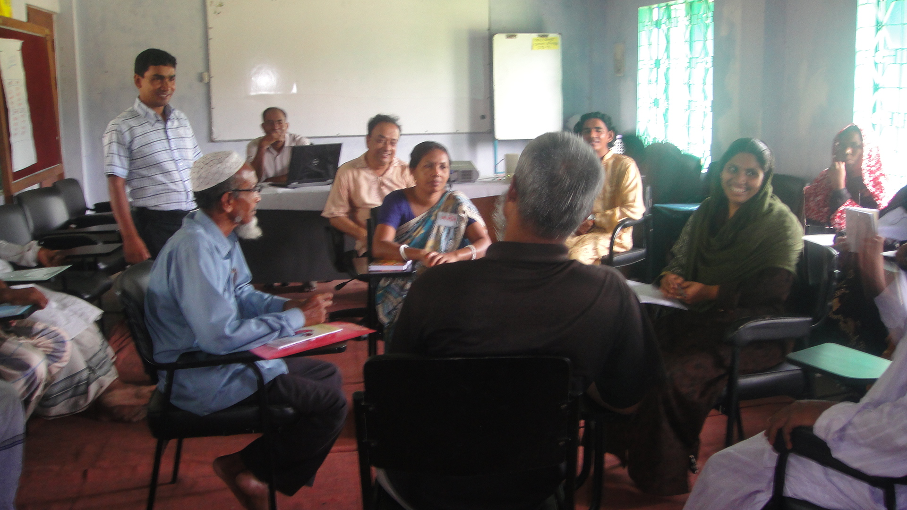
FACTS: Injury is the fifth leading cause of death and disability worldwide. The majority of disabilities in Bangladesh are caused by injuries resulting from different types of accidents (traffic accidents, burns, electrocution, animal attacks, acts of violence and conflict).
In November 2007, Bangladesh ratified the Convention on the Rights of Persons with Disabilities, under which children with disabilities have the rights to full and equal access to any place that is open to the public, including schools.
The nation-wide community based Bangladesh Health and Injury Survey (BHIS) reported an estimated 70,000 annual deaths due to injury that includes 30,000 children of under 18 years. Road traffic injuries alone cause a loss of about 2% of GDP in Bangladesh. ☼

CAPACITY BUILDING OF SMC MEMBERS ON CHILD RIGHTS
School Managing Committee has a vital role to attain quality education as well as to establish child rights in the community. Especially, all noble initiatives taken
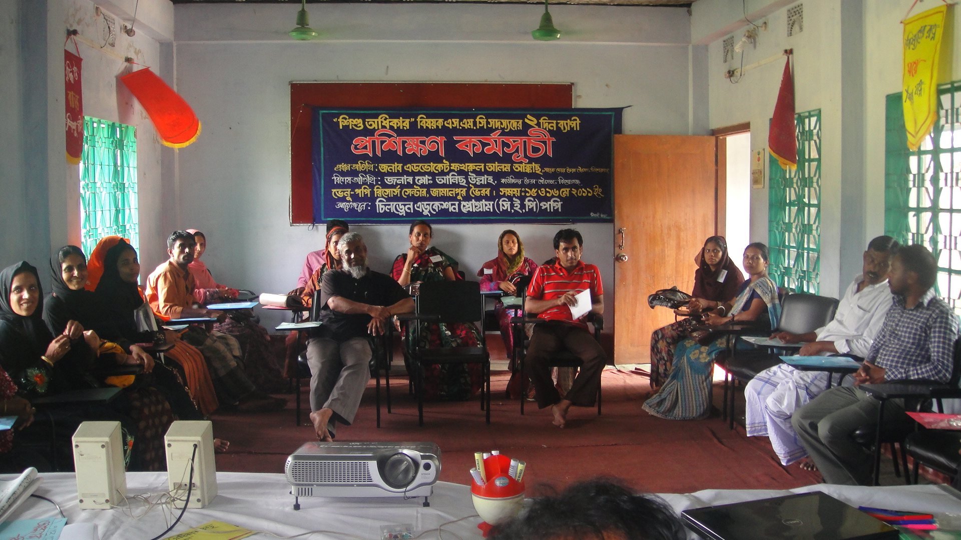
Worrkshop on Child Rights for SMC C
r by Managing Committees are extremely helpful to the development of the primary education system. But unfortunately SMC committee of primary schools in
Bangladesh did not play this role effectively. There are many factors behind. Lack of Knowledge about their responsibility is one major cause to function their role to change process. CEP Project is now working with the 10 community and Registered Primary Schools to support achieving the quality education. Every year 30 SMC members from three

Group discussion during workshop

schools is to train to build up their capacity. On 15th
and 16th May 2011, CEP Project organized two days long workshop at POPI resources center. 30 SMC members from 04 community and registered primary schools were participated. Former Mayor of Bhairab Municipality Mr. Fokrul Alam Akkas was present and inaugurated the workshop.
“I congratulate that initiative. Organizing such kind of workshop would gear up the knowledge to the members of SMC who would be able to make positive change to the school as well as community” said Fokrul Alam Akkas, in his speech. During the workshop, different issues like understandings and implication of child rights, liability and responsibility of SMC members were discussed. Participants actively shared their opinion.
“If ‘we’ could get it right, a lot of good could come of it. If ‘we’ get it wrong, an opportunity of full potential could be missed and forever be lost.” said Mamun Miah, Chairperson and land donor of Imamerchar Community Primary School. ☼

WHERE THERE IS A WILL, THERE IS A WAY
A story of Yasin
Everyday Yasin spend his busy life. In early morning he attends in coaching class conducted by the school. Then from at 12.30 p.m. he studies in regular class in grade-III. At 4.30 p.m. school is finished. But Yasin’s work not yet finish.
“I am a member of poor family. To buy our food, I am to earn money. At the evening, I go to the Railway warehouse to collect Kerosene. After vacant oil from

drum, some oil remains as a residue in the drum. I, like other boys, try to collect this oil by using sponge. Sponge is to tie at one end of the stick and send it
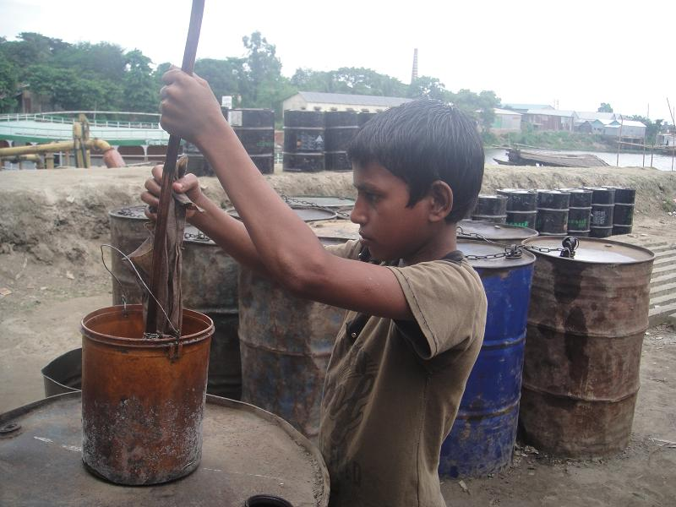
Yasin is collecting kerosene

inside the drum. Then residue oil absorbs by the sponge and we collect it. Everyday I collect ¾ liter Kerosene oil and sell it to the retail market at the rate of 30/35 Tk per liter. At 10 p.m. I return home and give my money to my mother’s hand.” said Yasin.

Despite the hard labor in every day, he did not leave his school because of his great interest to education.
“Though Yasin is a working child but he hardly misses the classes. He is so much attentive in class.” said his class teacher Mrs. Jorna Begum.

Yasin admits his life in difficult but he has big plans for his future. Yasin is in the process of completing primary education through POPI organized formal primary school and then will continue his study by receiving vocational training.

FACTS: According to the report of Bangladesh Bureau of Statistics, 7.9 million children are working as a child labor throughout the country. There are 430 forms of child labor identified in Bangladesh where 67 forms are hazardous. Millions of children across Bangladesh are forced to work, often in hazardous and low-waged jobs, to help support themselves and their families. ☼

GOOD PRACTICE
Coaching for Grade-V:
In 2009 Bangladesh Government started Primary Terminal Examination for grade V. It is the first public examination for the student hood. It is a remarkable step that was taken by the Government to improve and ensure the quality of primary education.
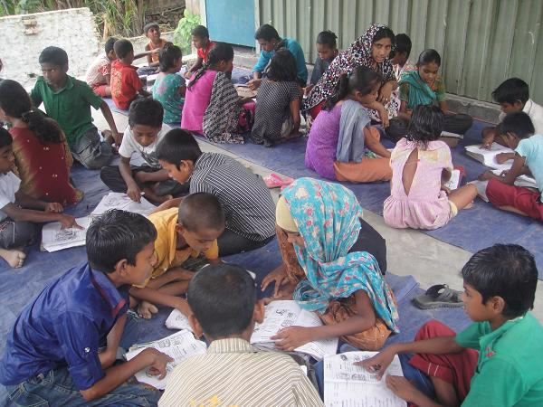
Although this decision has been appreciated by all but it also create tense to the students as well as teachers due to expectation of guardians and community. That also affected our POPI organized Formal Primary Schools teachers a great deal of. They are tremendously trying to achieve success in the Primary Terminal Examination. Since students did not have the
Performing coaching class in M.F.Alam FPS

ability to hire a private tutor as most of the students of these schools are come from poor families, then teachers have been started free coaching for their grade-V students.
Motivated by the last year success, from January of this year, this coaching was started. No extra honorarium is to give neither from the students nor from the project to the teachers. Teachers are doing it by their own initiative to achieve best result.

“We are always encouraging our teachers to conduct coaching class effectively. In the SMC meeting, we have taken decision to visit and look after the coaching class by all members periodically. In the visit, I have seen that the attendance in coaching class is remarkable.” said Mr. Cento Miah, a SMC member of Pultakandi Formal Primary School.

“Last year our school scored the best result among the others schools in this Union. By the best of our effort, this year we will continue our success.” said Rafia Khatun hopefully, Head teacher of Mirerchar Formal Primary School.

Child to child learning:
POPI organized formal primary schools are established within the poor and excluded community where most of the guardians of the children are illiterate. Therefore children usually did not get any help from their parents to prepare their lesson. Majority of the children learn absolutely from school. Out of school, they remain detached from book.
All POPI organized formal primary schools introduce child to child learning approach to hold the children in education.
Children learn from children at their home.

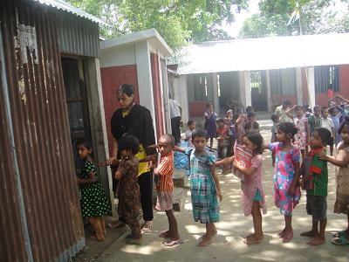
Every class teacher already formed groups with 4/5 children of neighbor children. A group leader for each group was also selected who lead the group. Every group sits in the yard or varanda or any other suitable place in one’s house out of school time. They prepare their home work, share their learning and teach one another. Teachers are look after the group activities by home visit but no more interfere. Children meet in group in their suitable time, suitable place and also select their learning needs instead of waste time.

“By the child to child learning approach Children learn organizing capability, respect, communication ability and decision making skill. Although all groups are not active equally but active participation gradually increased. This approach is highly appreciated by the community.” said Rina Akter, Head Teacher of Md. Ali Formal Primary School.

Child-to-Child learning is a rights-based approach to ensure children's participation in education and development that is grounded in the United Nations Convention on the Rights of the Child (CRC). Through participating in Child-to-Child activities the physical, social, emotional, moral and intellectual development of children is enhanced. ☼

JOINT INITIATIVE THROUGH COMMUNITY ENGAGEMENT
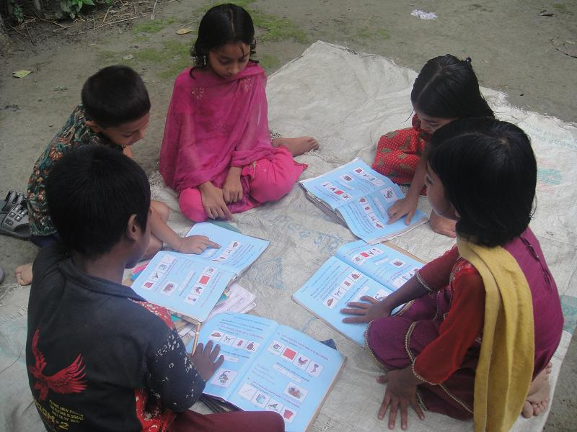
If we look at the history of educational development in this country, we would find that the general public has played a major role in establishing and maintenance of educational institutions. They have demonstrated that the educational institutions are the hearts of a developing society. When the link between the community and the educational institution is lost, its existence becomes endangered.
If the Managing Committee, the teachers and the parents do the duties accordingly, success is happened there.
Build up a new ECD center:
CEP Project is being working with the Roghunathpur community primary school since 2007 and giving support to develop the quality of education. From the beginning, this school supported with one ECD center by the project with two shifts. Being the catchment’s area so large, a huge number of students enrolled
every year in this school. To increase the school performance, SMC wants to construct another room for ECD class. In the SMC meeting, teacher, SMC members and CEP Project staff agreed to construct new class room for ECD with a condition that CEP Project will only give roof corrugated tin but others
Children are entering in their newly build class room .
bbbbbbbbb b
things should have to manage by the community. After meeting, within a short time, a new class room for early learner was established and class has been starting from February 2011.
It mentionable that Roghunathpur Community Primary
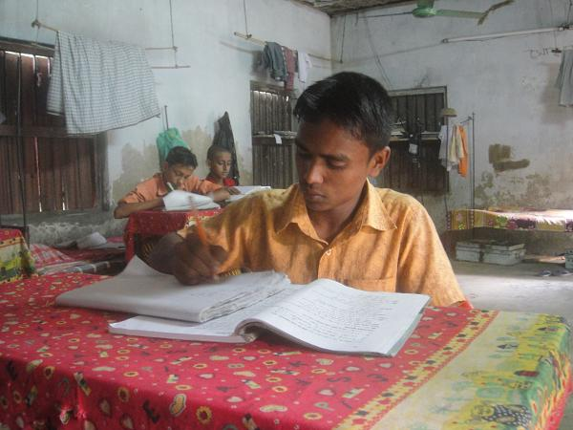
School were enrolled 544 children in different classes while 126 children were enrolled in class one. Out of 126 children only 60 children have got school preparedness opportunity through ECD center. Guardians are now well known about the importance of Early Learning before formal schooling. In the meeting, guardians reflect their intention to admit all the children in ECD center. For that perspective, School Managing Committee agreed to run two shifts in two class rooms to cover the whole early learner in the catchments.
“Being the construct another ECD center, now we are capable to enroll more children towards their development and prepare them for primary education.” said Monira Begum, Head Teacher of Roghunathpur Community Primary School.

Local Government (LG) Fund for Formal School:
“We are suffering for class room shortage in our school. Although we constructed a class room with a support of CEP project but because of deficit budget, it was uncompleted. Therefore we could not able to use it.” said Jorina Begum, Head Teacher of F.M. Alam Formal Primary School.
In the SMC meeting, SMC members were agreed to apply to Bhairab Mayor and respective Counselor to allow budget for completing the rest of the work. Accordingly they applied to Bhairab Municipality to sanction budget for this school.
The personnel from Bhairab Municipality visited the school and recommend allocating budget for this school.
In May 2011, fund was allocated to the school. By this
budget, ground filing, floor construction and set up a
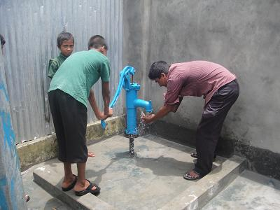
Tube Well is set up with the support of LG

tube well with protection wall was made. “Now we overcome the crisis of conduction class as well as
Uzzal prepare his lesson

availability of safe drinking water” said Jorina Begum

FACTS: 89% percent of Government Primary School (GPS) and 85% of Registered Non-Government Primary School (RNGPS) have potable water supply mainly from tube wells and in few cases from tap supply. However, only 71% of these tube wells were reported to be in working condition in GPS and 63% in RNGPS. ☼

A STORY OF A ORPHAN CHILD.
Chanchora orphanage was established in 1958 at Jamalpur village in Bhairab Upazila. From the
beginning of its operation, many victimize children of our society have been supporting from this orphanage.
To provide the better assistance towards their lives and education, POPI has been giving support from 1999 through CEP Project. Now 44 boys were supported by the projects, who are studying in different classes from play group to class-X. Uzzal Miah is one of them.
The life of Uzzal Miah is not as usual like other children. He lost his father at the age of 04 (four). His family had fallen into poverty as they have no income source. His mother admitted him in the Chonchora Orphanage at the age of five. Later his two younger brothers were also admitted in the Orphanage. In 27th October, 2008, it was another sad day for him when he lost his mother.
He enrolled in Jamalpur Technical High School in class-I. He studied there up to class-VIII and always he scored 1st or 2nd place during his study. He got assistance of taka 100 in each month from the school
as a meritorious student. In 2011, he participated in the competitive examination to enroll in Govt. Vocational Training
Institute and scored 6th place. With the financial assistance from the project he finally admitted in general electric section of this Vocational Institute.

“Uzzal suffers a lot during only 14 years of his life but it did not weaken his strength to live. He does not even take-care only his study but also take-care of his brothers.” said Mr. Baten, House Tutor of the orphanage. ☼

Voice of Children

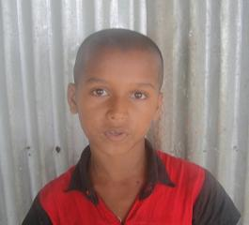
“I want to learn, get an education. I want to be a Doctor.”

Saiful Islam, (9), Class-III
Pultakandi Formal Primary School

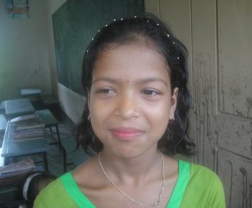
~~~~~~~~~~~~~~~~~~~~~~~~~~~~~~~~~~~~~~~~~~~~~~~

“I would like to become a teacher and then I would teach my people.”

Aruna Begum, (10), Class-IV
Akbor Nagar Registered Non-Govt.
Primary School

~~~~~~~~~~~~~~~~~~~~~~~~~~~~~~~~~~~~~~~~~~~~~~~
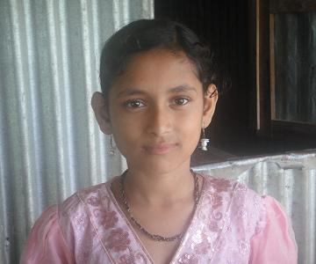
“I am in class-IV but I want to study more. I would like to become a well educated person.”

Tamanna Akter, (10), Class-IV
Mirerchar Formal Primary School

~~~~~~~~~~~~~~~~~~~~~~~~~~~~~~~~~~~~~~~~~~~~~~~
An ideal teacher
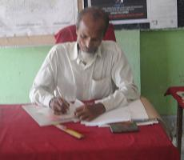
Riaz Uddin, 57, is a Head Teacher of Hazi Kalu Registered Primary School, is one of the ten
Community & Registered Primary Schools that have been supporting by the project since 2007.
In 1974, he completed Higher Secondary Certificate Examination Successfully and then he started his job as a teacher.
He acquires honor from the students, guardians and community as a good teacher.

After 35 years of dedicated service as a teacher, he will be retired from July 2011.
We give gratitude to him from our team for his life-long dedication towards nation.

“Be proud, you are a teacher, nation depends on you” ☼

